COMP 3613 Software Engineering II

Fazeeia Mohammed - Product Owner

Journal of A Product Owner

What does a product owner do?

The product owner's purpose is to organize the Product Backlog. This includes clearly expressing Product Backlog items, ordering the items and optimizing the value of work the development team performs. The product owner also ensures that the product backlog is visible and determines what the team will work on next.

What is the product?

The product is a chatbot capable of collecting the symptoms of a user and scheduling an appointment to visit a doctor.

*.*

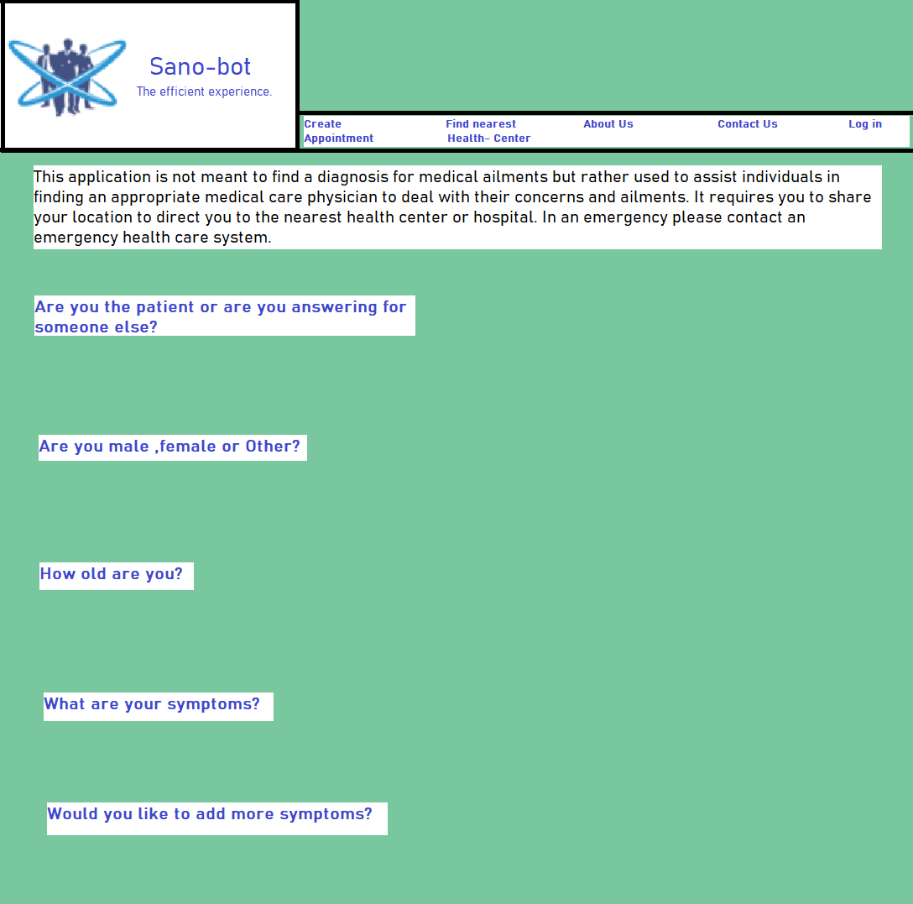

## Draft 1.0 of system output.

## Product backlog for Sprint 1:

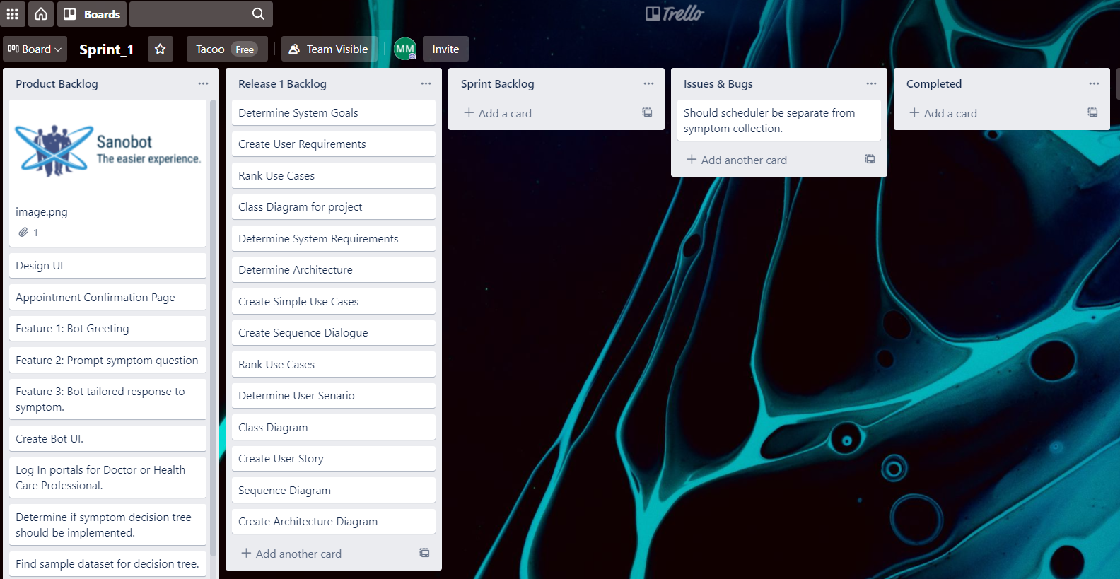

## Week 1 :28th-3rd September/October

|  |  |
| --- | --- |
| Monday | Conceptualized a User Requirements.Draft 1.0 was completed at this time as a rough sketch. |
| Tuesday | Researched DialogFlow for use with Angular UI. The idea of a slang interpreter was contemplated. |
| Wednesday | Contacted San Fernando General for recent research on data collection methods for doctors and nurses. An issue with communicating the correct symptom was highlighted to me by numerous doctors. |
| Thursday | Conceptualized the System Requirements. Researched how a slang interpreter would work and if it was feasible. |
| Friday | Collated all the requirements and submitted documents. |
| Saturday | Received doctors call back to get a flow of dialogue for the system. |

## Sprint 1

## Week 2 :5th-10th October

|  |  |
| --- | --- |
| Monday | **Sprint Meeting 1:**  Determined that the slang interpreture is out of the scope for the design. Priority 1 getting a dialogue as close to natural as possible, and determining an Angular UI.The development team discussed the storage of the information collected from the user and the tools for making a decision about the appointment. My research helped me realize that compassion and etiquette plays an important role in this specific data collection exercise and the bot should greet users accordingly. |
| Tuesday | **Sprint Meeting 2:**  Successfully determined a small dialogue starting point.I proposed the name of the bot be ‘Sano-bot’ which was accepted by the development team. |
| Wednesday |  |
| Thursday | **Sprint Meeting 3:**  Determined that a .txt file with the dialogue will be first created and used to read in lines.I outlined my proposed questions to the development team where they deliberated and streamlined the process within the constraints of the software being used. ***DialogFlow CX***. |
| Friday | Searched for examples and found a HR communications handbook. |
| Saturday | **Sprint meeting 4:**  Feature of a loop for collecting symptoms questioned :  Is this really the best method to do this?  The development team and I simulated a conversation with a doctor to get a feel for what should be accomplished by the bot. The communication of how dynamic the interaction has to be is intimidating so they decided to build each symptom separately. |

## Week 3 :12th-17th October

|  |  |
| --- | --- |
| Monday |  |
| Tuesday |  |
| Wednesday | **Sprint Meeting 5:**  Roganci offered this at the SCRUM meeting. <https://www.youtube.com/playlist?list=PLIivdWyY5sqK5SM34zbkitWLOV-b3V40B> .I questioned the process of integrating both a website and the bot.The development team discussed invalid responses and how the system would deal with them. We did our User and System Requirements |
| Thursday | **Sprint Meeting 6:**  I offered <https://chatbotslife.com/integrate-dialogflow-api-ai-bot-into-website-661a70b22199> at SCRUM meeting as a solution to the previous problem. |
| Friday | Discussed use and integration of Sanobot. |
| Saturday | Use case diagram-2 hours . The Use case diagram I attempted is not included in the final project because it was deemed too detailed. |

The majority of my time was spent learning how to code the bot using different intents on DialogFlow CX.

## Week 4 :19th-24th October

|  |  |
| --- | --- |
| Monday | Completed outline for dialogue- 10 hours. We discussed the priority ranking for the Use Cases.We selected a Create an Appointment, View Appointments and View Doctors Appointment as our highest ranking use cases. |
| Tuesday | Completed Architecture Framework: 2 hours |
| Wednesday | The group needs to adjust the trello. The sprint 2 trello is adjusted and new tasks are added to the product backlog |
| Thursday |  |
| Friday | Trello adjusted. |
| Saturday |  |

## Retrospective:

As Product Owner, I created the Sprint and the Sprint backlog. To keep the back and forth between the user and AI-bot as close to real life as possible, I researched the roles of health care workers and whose responsibility it was to collect symptom information from the patient. There is not a formal bedside account implemented in Trinidad and Tobago. In this country it is customary for the nurses to preliminarily interview the patient to collect specific information before passing it off to the doctor. The process is hardly streamlined, it consists of a mess of paperwork, in consistent file keeping, delays and long queues. Ideally Sano-bot should relieve some of the queuing times and data collection.

As the product owner the continuous maintenance of the product backlog is my responsibility so once a week I try to revise the task to streamline the process.These four sprint meetings helped shape our User and System Requirements. As the product owner I was able to gauge the capability of the DialogFlow CX and the appropriateness of its usage in this implementation. We were also able to understand what would be needed for an API to be implemented between the bot and a route.

## Product backlog for Sprint 2:

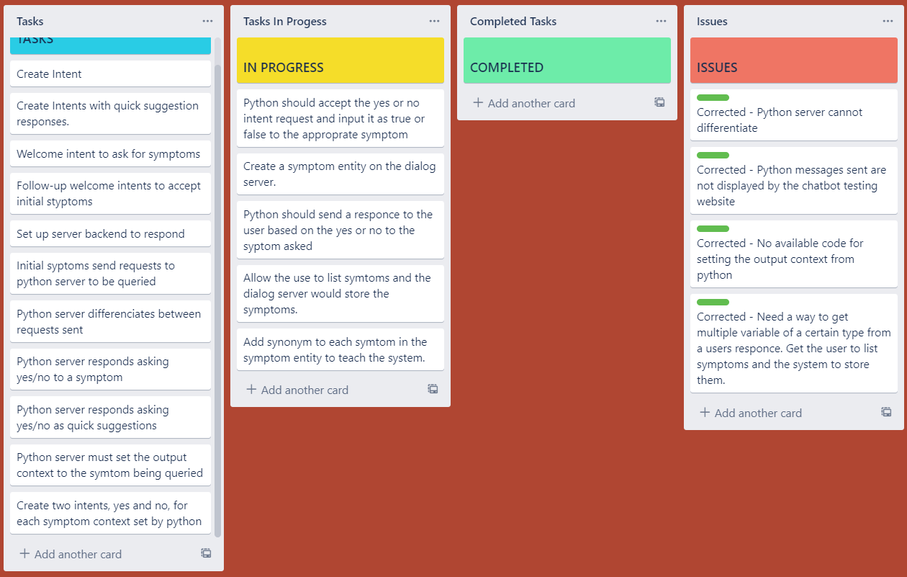

## Sprint 2

## Week 5:26th-31th October

|  |  |
| --- | --- |
| Monday | Decided the trello needs to be organised.  **Sprint Meeting 7 :**  Discussed whether the scheduler should be programmed on the DialogFlow. No conclusive answer was found. Collectively we decided to do some research.We decided that we would split the last two sprints into requirements 1 to 3 and then 4-6. The Bot has the greeting and symptom request however the bot is limited in the options it can give. To truly build the best chat bot with a relevant futuristic scheme we would have to consider a mobile app with the least amount of input. The design seems input heavy. However compromising on medical care seems like a bad idea . A revision on the part of the bot can be to offer different languages. That can be a new requirement to cater for spanish speaking individuals living in Trinidad. |
| Tuesday | Did some intents with the bot using DialogFlow CX. There are no guides on how to use this software so it was up to us to experiment with it. |
| Wednesday | Tyrese eye exam*.  **Sprint Meeting 8:**  We discussed the use of DialogFlow ES vs CX. It was apparent that CX would be more difficult to train due to a lack of guidance on how to go about training this bot. We agreed to use DialogFlow ES .Tyrese researched the technology and demonstrated what he had trained the bot to do. |
| Thursday | Roganci’s Orthodontist exam. |
| Friday | **Sprint Meeting 9**:Coordination has been a little difficult.I did some greetings with the CX bot. Kommunicate does not display the text sent back by the python back end also it is a free trial product that would not be available to us in a months’ time. |
| Saturday | I unfortunately had to remove a tooth and it caused some unforeseen delays in work. |

## Week 6 :2nd-7th November

|  |  |
| --- | --- |
| Monday | **Sprint Meeting 10**:  Created intents, taught bot synonyms for different symptoms. Roganci researched the ES capability of entities and entity listing.We discussed Python being used in the back end |
| Tuesday | Compared and contrasted different chat-bot systems in order to design a more competitive bot. Astonishingly the bot does not allow for multiple programmers to work on it at the same time because saving over writes the bot. |
| Wednesday |  |
| Thursday |  |
| Friday | **Sprint Meeting 11:**  We decided on plans for a small user interface. I accordingly planned the tasks needed to be done to accomplish this. This is the last meeting for this sprint so we organised the next trello and we discussed the implementation of a decision tree. As the product owner I made the ultimate decision to focus the team on a front end rather than continuing with Kommunicate which was going to expire for us soon. |
| Saturday |  |

## 

## 

## Retrospective:

During times of COV-ID making dentist appointments and general personal care has been made more difficult and unfortunately it was expounded this week. It is an unfortunate occurrence however everything is not within our control.

As a product owner, the logic used to design the bot was a little difficult at first however I quickly realized that the requirements and the capabilities of the software did not match. As such, compromises between the requirements were made. There is a distinction between being a developer and a product owner that is fully appreciated in the strategic move from DialogFlow CX to ES. The DialogFlow ES from my understanding as a product owner is small scale however it learns from patterns of the user whereas DialogFlow CX is more robust and structured. I am however in the role of product owner and for the SCRUM method to work successfully I must commit to the roles outlined and allow the development team the freedom to choose how to execute the sprint goals. Also DialogFlow CX is a paid service after a 30 day trial so it is not feasible to continue down this path. It is for these reasons we have switched to DialogFlow ES.

## Sprint 3

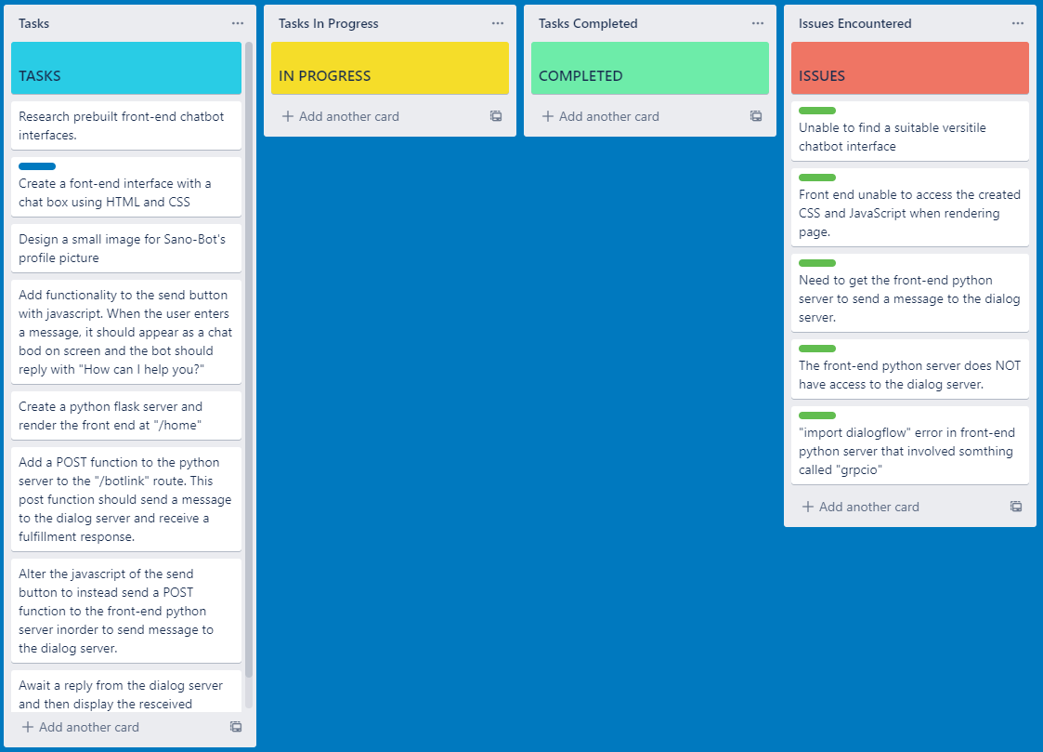

## 

## Sprint 3

## Week 7 :9th-14th November

|  |  |
| --- | --- |
| Monday | Worked on the decision Tree realized the results of the decision tree were useless because of accuracy of the f-score for this data set. This data set is bias.I believe a decision tree can be implemented however it would have to fit like a glove. As such random datasets may not be useful. An ideal instance of this is the occurrence of dengue which is a tropical disease however the dataset did not represent this. I did not relay this to my team since we were now focusing on a front end to our bot.  **Sprint Meeting 12:**  We researched interfaces for the bot. When the project started I saw integration using Angular. We discussed the tasks for Trello.We discussed the front end for the bot. We searched for pre-built frontends and their integration capabilities.We also discussed keeping the cost at $0 because most chat-bot front ends for hosting cost a lot of money. As such I opted to have a front-end made rather than pay for one. |
| Tuesday |  |
| Wednesday |  |
| Thursday | **Sprint Meeting 13:**  As we have accumulated more symptoms I have undertaken the differential distinction of these symptoms since the differences can be minor nuances.  I showed my team images of the initial interface design I had. I told them that I simply wanted light welcoming colours and definitely not red. The team referred back to my architecture diagram which the developers did to reflect the changes we made. We looked at different hosting sites and decided to build an interface like Kommunicate. My initial architecture still stands.We also decided that Sano should send and receive POST requests.  Tyrese and Roganci created the logo/ image used for Sano-bot. We discussed backend mechanics and fulfillment messages. |
| Friday | CSS Materialize is pretty and welcoming so we decided to use this for the front end of the bot. Getting a POST function viable was a persistent issue.  <https://medium.com/swlh/working-with-dialogflow-using-python-client-cb2196d579a4>  We tried to implement the sample code we found but we got more errors while accessing the dialog servers. I decided I needed a break. |
| Saturday | A solution was found. The post function was implemented and tested.And it works. |

## 

## Retrospective:

Ideally after much thought I proposed that it be a cluster or a frequency association of some sort. After studying both clinical biochemistry and biology I understand that the decision making process done by a doctor is done on a dichotomous decision making tree. Almost like a nested tree. Where multiple queries about a specific symptom is made and then a specific disease or ailment is determined to be the culprit.

Most symptoms need to be confirmed by biological testing. Non-invasive testing is the trend and is possibly the future of making SANO-Bot more viable. I tried to communicate these ideas to my group. This idea can go further with the integration of wearable technologies.We have accomplished everything that we set out to do thus far. We have a working bot that can collect symptoms from users and is responsive in sending POST request to our backend server. We are ultimately cheap creatures and are using repl to host our front and back end.

## 

## Sprint 4

## Week 8:16th-21st November

|  |  |
| --- | --- |
| Monday | **Sprint Meeting 14**  This was the final sprint meeting for sprint 3. We did a trello for a Sprint 4. Hypothetically this would be the sprint where we implement a backend decision making process. |
| Tuesday |  |
| Wednesday | **Sprint Meeting 15:**  We discussed any final things we would want to change, add or remove. |
| Thursday |  |
| Friday | I shared the previous dataset I found however Kaggle is over runned by COV-ID prediction applications |
| Saturday |  |

## Week 9 :23th-28th November

|  |  |
| --- | --- |
| Monday | Tyrese is relentless. |
| Tuesday | Finishing touches on the application was made |
| Wednesday |  |
| Thursday | **Sprint Meeting 16:**  I showed Tyrese the Gantt chart I did and urged my members to start the final write up. As in doing the reflections and burndown chart. I was distracted by searching for datasets to do a better decision tree. |
| Friday |  |
| Saturday |  |

Week 10 :30th-4th December

|  |  |
| --- | --- |
| Monday |  |
| Tuesday | Interview. |
| Wednesday | Started structuring final document. |
| Thursday |  |
| Friday |  |
| Saturday |  |

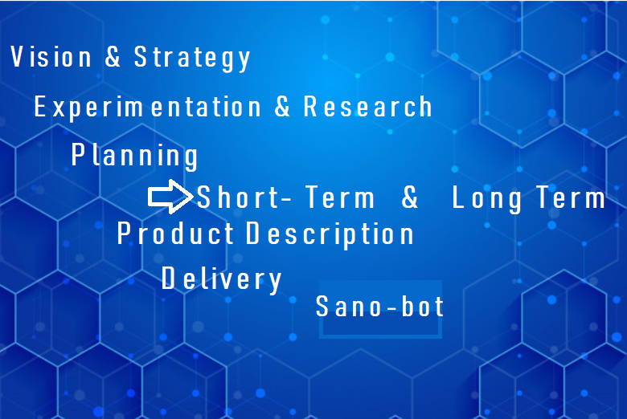

## Final Retrospective:

As the product owner the SCRUM framework practices need to be strictly adhered to for it to work. Each scenario is different so it must be tailored to fit the individuals you are working with.

The process is one of continuous learning and change. Being responsive to change and not holding on too closely to a fixed structure ensures for a successful enterprise.

I conceptualized the idea of a responsive and dynamic interaction for users to communicate vital information with respect to appointment making early in the semester. I communicated to my group initially with great trepidation simply because there always seems to be a barrier of communication surrounding my background as a Biological Sciences student. Personally the world seemed hyper-focused on COV-ID-19 and it highlighted to me the poor state of affairs most hospitals are in especially in Trinidad and Tobago. Taking up the mantle of product owner during this exercise seems natural since I am a creator at heart but additionally I abhor the medical care system and the state it seems to persist in. My greatest challenge during this exercise is that I am incapable of saying no in situations that demand it. Ultimately I feel as though in certain situations I should have stuck to my ideals however my design team were also flexible which allowed for compromises that ultimately resulted in a successful project. The development team was also highly capable and were able to design work arounds for problems I highlighted and because of this the transition from DialogFlow CX to DialogFlow ES was seamless because the development team were able to adapt quickly. Initially the workload was intense. I had to determine what should and should not be part of the project. **What would work with more resources and time versus what did work immediately with the ultimate goal of a working product, was always at the forefront of my mind when attempting any task, communicating ideas and researching technological tools.**

**So Why use agile in the first place?**

The SCRUM agile method is the only method that would be able to adapt to novel technological needs as the product development moved forward. We were able to adapt to changes that research deemed necessary at the time without starting over and still have a functional product at the end. I created the ultimate requirements of the system and initialized the research areas of the project in a streamline way.Ultimately picking and choosing what was viable versus out of scope. It was not a traditional leadership role that I am used to and it is a very Darwinian methodology. I researched my role and discovered a fierce distinction between a product owner and a product manager role. As a product owner my role was very tactical versus a manager who is strategic. Every sprint meeting seemed like a relentless battle between communicating my ideas and organizing the tasks that should be done based on my developers' understanding of what was going on. I occasionally said no to ideas that were out of scope or not viable because of my research. For example the decision tree for the symptoms prediction lacked an appropriate dataset. I found symptom datasets online using Kaggle and ran decision tree calculations using a one hot vector layout on the dataset and it yielded no functional decision making that could be implemented. I researched clusters and realized it would be a more functional solution.

Conclusively, it was an enriching experience where I learned a distinct way of information flow.